- Download a small sample of IPL match data (CSV) with some missing values in player stats. Load it using pandas and print the number of missing values in each column.
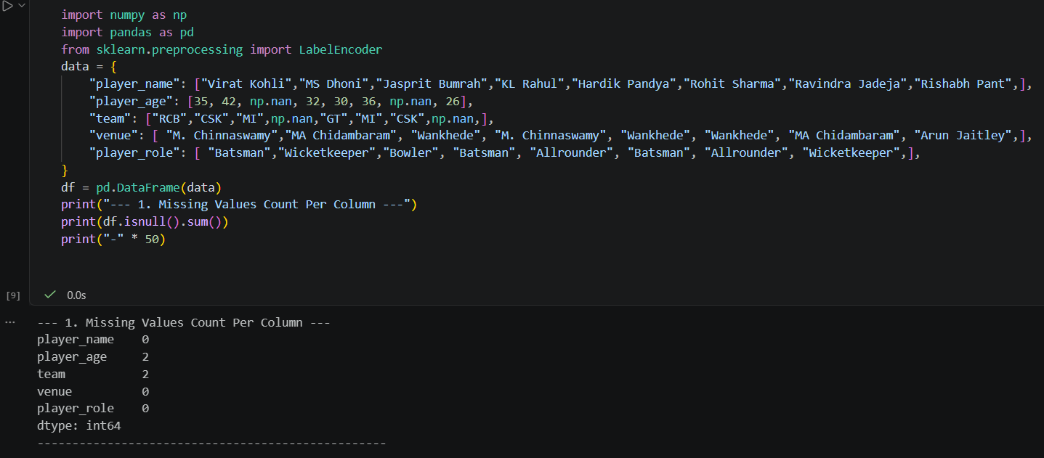

- For the 'player_age' column in your IPL dataset, fill all missing values with the median age using pandas' fillna() method and display the updated column.

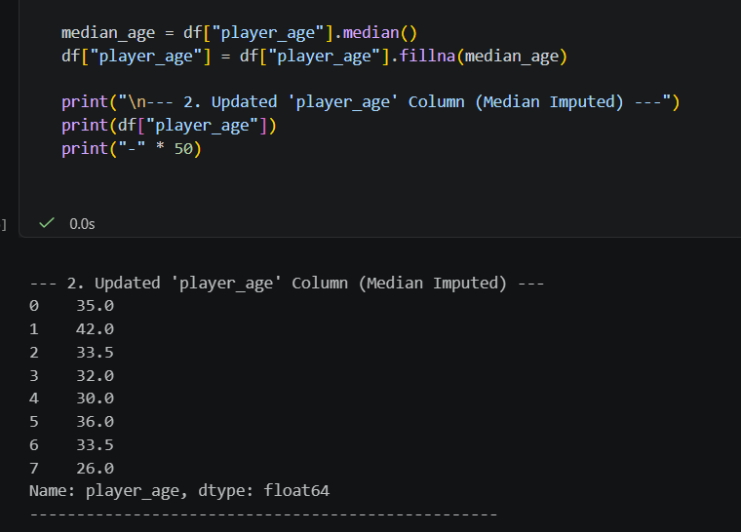
- Suppose the 'team' column in your IPL dataset contains missing values. Replace all missing team names with the constant value 'Unknown' and print the first 10 rows.
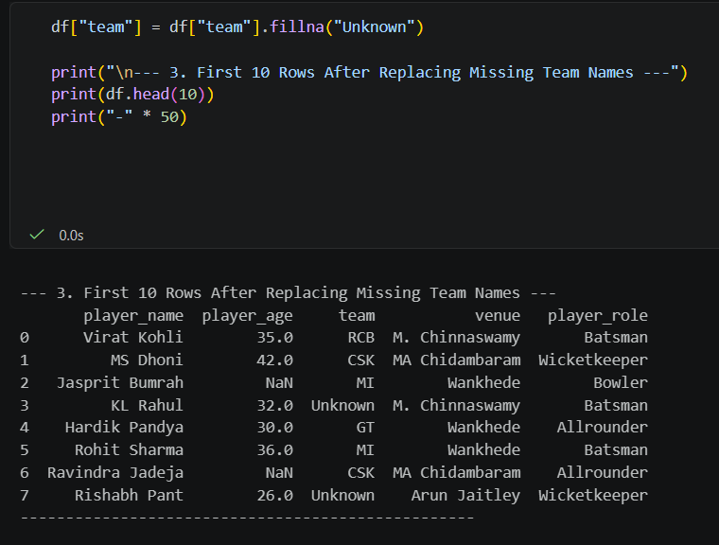
- Take the 'venue' column (categorical) from your IPL dataset and apply one-hot encoding using pandas' get_dummies(). Show the resulting DataFrame with the new columns.
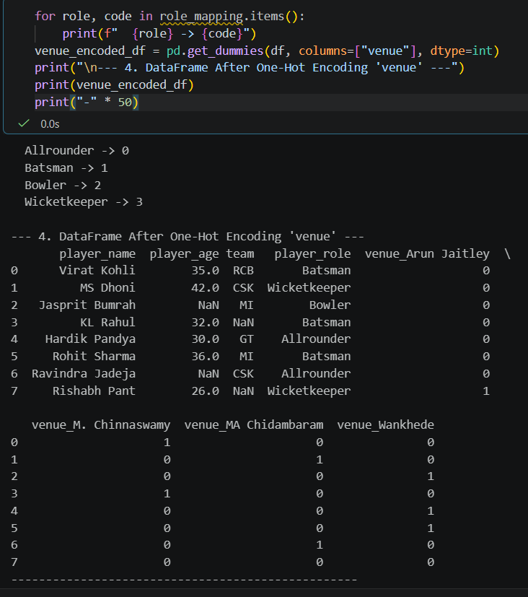
- Use LabelEncoder from sklearn to encode the 'player_role' column (e.g., Batsman, Bowler, Allrounder) in your IPL dataset, and display the mapping from original roles to encoded values. Use LabelEncoder's classes_ attribute to see the mapping.

